 | Air University Aerospace & Aviation Kamra Campus  Department of Computer Science

Name: Muhammad Osama Khattak Roll No: 235140
Course: Data Science Lab Lab: 7
Teacher Name: Sir Mustajab Hussain

Task 1: Clean Student List
Screenshot 1: Cleaned Students Table
• I loaded Students.xlsx into Power BI and opened it in Power Query.
• I removed blank rows and duplicate students using StudentID.
• I used Trim to remove extra spaces and Capitalize Each Word to fix the Name and Department columns.
• The final table has 9 clean rows.
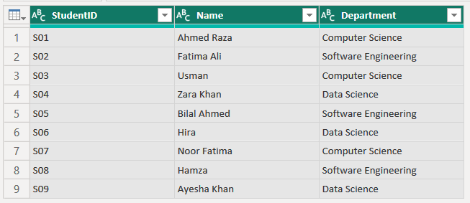
Screenshot 2: Department Filter Check
• I opened the filter on the Department column to check the values.
• Now there are only 3 departments (Computer Science, Data Science and Software Engineering), so every name is written the same way.
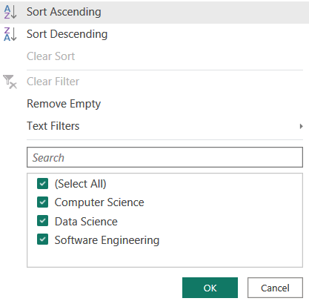
Task 2: Clean Products CSV
Screenshot: Cleaned Products Table with StockValue
• I loaded Products.csv and renamed Product Name to Product and Qty to Stock.
• I trimmed and capitalized the Product and Category columns.
• I replaced N/A with null in Price and Stock, then changed both to Whole Number.
• I added a custom column StockValue = Price × Stock.
• Column quality shows 0% errors. StockValue is null only where Price or Stock is missing (P03 and P05).
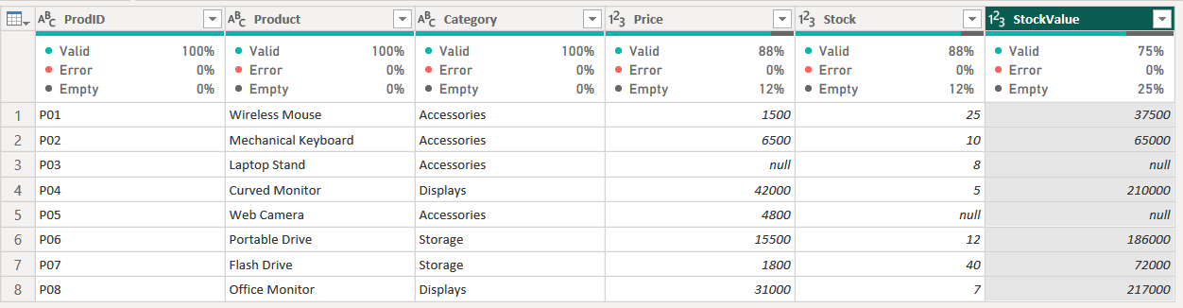
Task 3: Append Monthly Sales
Screenshot: Combined Q1 Sales Table (Sales_Q1)
• I loaded the Sales_Jan, Sales_Feb and Sales_Mar CSV files.
• The first append gave two region columns because one file had “region” in small letters.
• I renamed it to “Region” and appended the three files again into Sales_Q1.
• I set Date to Date type and Amount to Whole Number, and disabled load for the monthly queries.
• The final table has 15 rows and only one Region column.
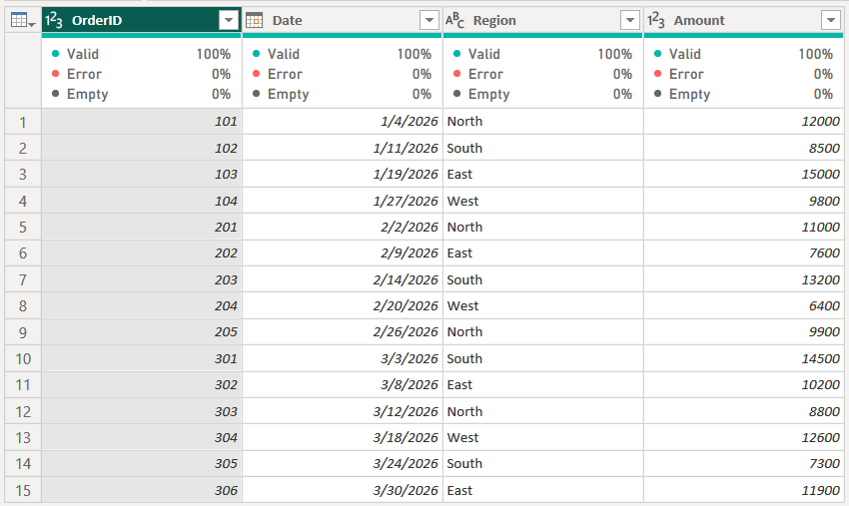
Task 4: Merge Enrollments with Courses
Screenshot: Enroll_Details (Left Outer Merge)
• I loaded Enrollments.csv and Courses.xlsx.
• At first only some rows matched because CourseCode in Courses had extra spaces and small letters, so I used Trim and UPPERCASE on it.
• Then I merged the tables with a Left Outer join and expanded CourseTitle and CreditHours.
• All 10 enrollments are shown. E10 has null because course CS999 does not exist in Courses.
• Row counts of each join: Left Outer = 10, Inner = 9, Full Outer = 11, Left Anti = 1.
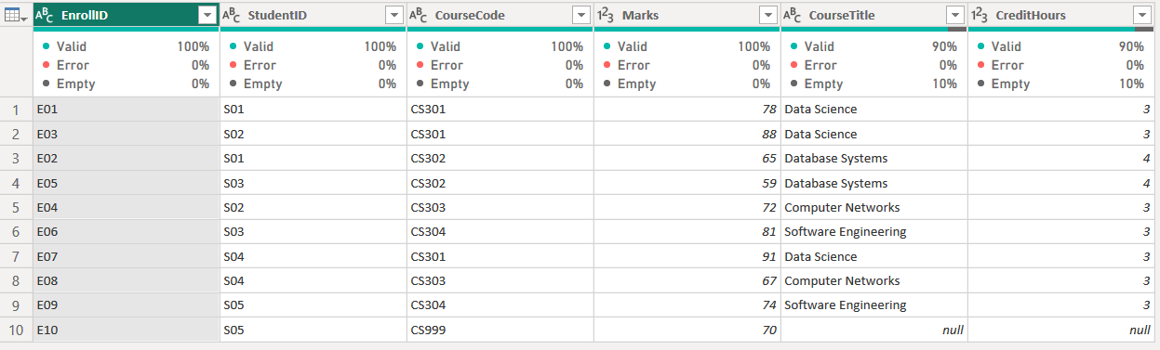
Task 5: Split Columns and Derived Fields
Screenshot: Employees Table after Split and New Columns
• I loaded Employees.xlsx, then trimmed and capitalized FullName.
• I split FullName by space into FirstName and LastName, and split Dept_City by “-” into Department and City.
• I removed “Rs.” and commas from Salary and changed it to Whole Number.
• I added AnnualSalary = Salary × 12 and an Email column (firstname.lastname@company.pk).
• Trim must come before the split, because a leading space would be treated as the delimiter and FirstName would become empty.
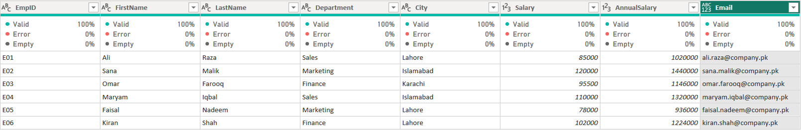
Task 6: Complete Results Workflow
Screenshot: Final_Results Table
• In Section A, I removed duplicate rows and replaced AB (absent) with null. In Section B, I renamed “Reg No” to RegNo.
• I added a Section column (A and B) and appended both sections into Results_All.
• I merged Results_All with Students_Info (Left Outer) to get each student’s Name and Program.
• I added Percentage = Obtained / TotalMarks × 100, rounded to 1 decimal.
• AU103 has null marks because the student was absent. AU111 has no Name or Program because this student is not registered in Students_Info (the Left Anti check found it).
